PAGE TITLE

Unearthed: Mining, People, and the Fight for the Philippine Earth

Definition - this part should not be included in the website—------------------------------------------------

What Is Mining — And Why Should You Care?
Every time someone drives an electric car, charges a phone, or installs a solar panel somewhere in the world, there is a good chance that a piece of the Philippines went into making it possible.
Mining is the process of extracting minerals — gold, nickel, copper — buried deep within the Earth. Open pits are blasted open. Mountains are dismantled. Rivers are redirected. And communities that have lived on that land for generations are left to face what comes next.
The Philippines is one of the world's most biodiverse nations — and one of the most heavily mined. It is a country trying to protect its extraordinary natural heritage while simultaneously digging it up to fuel global economic growth (ScienceDirect, 2024).
This is not just an environmental story. It is a story about people — Filipino farmers, fisherfolk, and Indigenous communities — who did not choose this, and who are paying the price for a world that does.

Insert
https://cri.org/wp-content/uploads/2025/10/Cover-Photo-768x474.jpg

Causes - this part should not be included in the website—------------------------------------------------

How Did We Get Here?

The world wants what's underground here.
The Philippines is the world's second-largest nickel supplier. In the first three quarters of 2023 alone, the country's nickel output reached 28.9 million dry metric tons — valued at ₱53.54 billion — driven largely by China's growing demand for stainless steel and electric vehicle batteries (Mongabay, 2024).
And that demand is only growing faster.

The Middle East crisis changed everything.
The Philippines imports 90% of its fuel from the Middle East. When conflict there disrupted global oil supply, the country faced one of its worst energy emergencies in recent history — fuel prices surged, the peso collapsed, and millions of Filipinos struggled to afford basic transportation and electricity (Christian Science Monitor, 2026).
The scramble for alternatives sent the world rushing toward electric vehicles, e-bikes, solar panels, and battery-powered gadgets. But here is what the ads for those green technologies do not show you: the nickel inside them is being torn out of Philippine mountains, at enormous cost to the communities living there.
Senator Sherwin Gatchalian declared that the global oil crisis could be a "turning point" that will accelerate electric vehicle adoption in the Philippines. "What's happening right now with petroleum prices is an eye-opener," he said (BusinessWorld / MEXC, 2026). And as EV adoption accelerates, so does the hunger for Philippine nickel.
A projected 60-percent rise in global nickel demand by 2040 is colliding with the growing harm from mining and climate change — leaving coastal communities more exposed and with far less protection than they deserve (Bulatlat / Climate Rights International, 2025).

The rules exist. They are just not followed.
https://ars.els-cdn.com/content/image/1-s2.0-S0959652624025630-gr3.jpg
In early 2024, the government fast-tracked mining permits under pressure from industry — a decision that advocacy groups warned would put communities and nature at serious risk (Global Witness, 2024).

Poverty leaves people with no other choice.
In remote provinces, mining is often the only income available. Communities are not choosing destruction — they are choosing survival. That distinction matters.

Current Status - this part should not be included in the website—----------------------------------------

Where It Is Happening Right Now

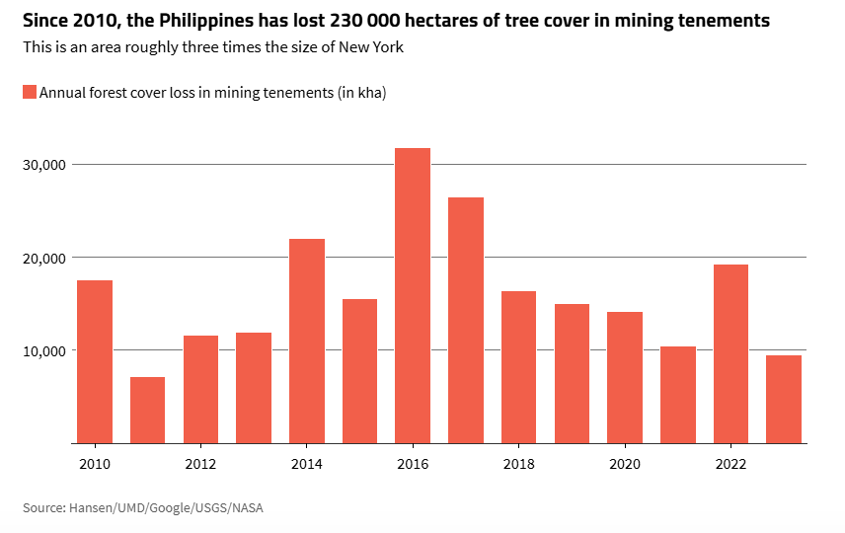
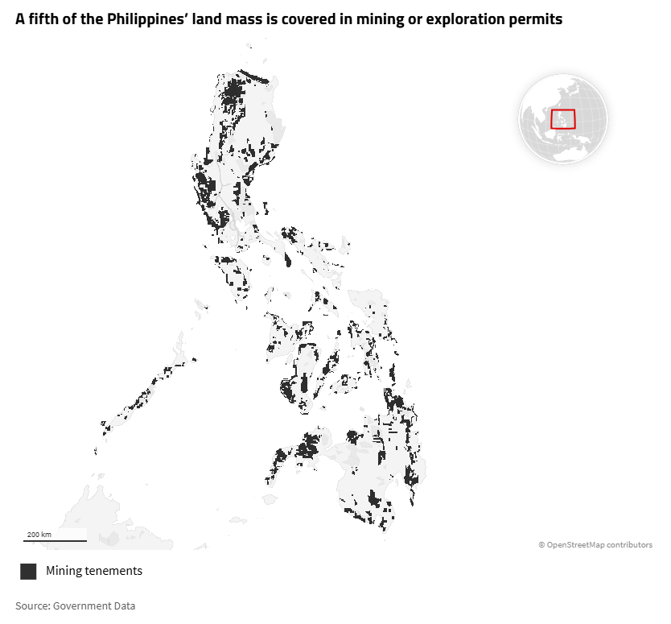

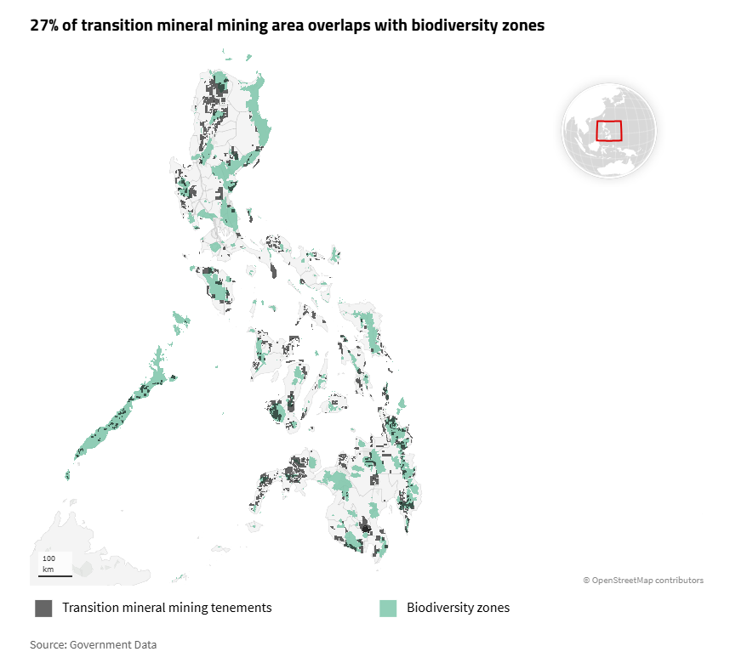
This is not an abstract crisis. These are real places. Real rivers. Real families.
The Caraga Region in Mindanao has 26 operating metallic mines — more than any other region in the country — 23 of which are nickel mines. In Surigao del Sur and Dinagat Island alone, companies have caused documented deforestation, water contamination, and health damage to local communities (Climate Rights International, 2024).
In Palawan — an island so ecologically precious it has been declared a UNESCO Man and Biosphere Reserve — eleven mining companies have been granted rights over 29,430 hectares of land. In February 2024 alone, one company received a permit to cut approximately 52,000 trees (Rainforest Rescue, 2024).
The Philippines mined ₱252.90 billion worth of metals in 2024. The vast majority of that nickel was exported — 92% to China alone (Mongabay / MGB, 2025). The wealth leaves. The damage stays.

Effects - this part should not be included in the website—----------------------------------------

How does it affect YOU?
You may not live near a nickel mine. You may never have set foot in Surigao del Sur or Dinagat Island. But what happens to those mountains, those rivers, and those communities is already reaching you - and it will only get closer.

The air you breathe is getting dirtier.
Residents living near nickel mines in the Caraga Region have blamed the mines for dust pollution during the dry season - the kind that settles in your lungs quietly, long before you notice anything is wrong (Mongabay / CRI, 2025). People in Dinagat Island and Surigao del Sur are now reporting respiratory and skin ailments they believe are linked to pollution from nearby mines (Climate Rights International, 2024). If you live downwind of a mine site - or downstream from one - your body is already keeping score.

The water you depend on is at risk.
For over 15 years, researchers have detected toxic chromium levels in Palawan's Togpon River at concentrations exceeding international safety standards. In September 2024, they recorded the highest levels ever observed in the entire history of their monitoring (Friends of the Earth Japan, 2025). This is not a distant river. This is the kind of water source that farming and fishing communities - real Filipino families - drink from, cook with, and bathe in every single day. When that water turns, there is no easy replacement.

The food on your table is becoming harder to produce.
In Dinagat Island and Surigao del Sur, fisherfolk have described how water runoff from nearby mines has made it extremely difficult - sometimes impossible - to continue fishing, the livelihood their families have depended on for generations (Climate Rights International, 2024). When fishing grounds are polluted and agricultural land is buried under silt, the communities that feed themselves - and others - lose everything. That ripples outward. Fewer fish in the water means fewer fish at the market. Environmental damage in one province quietly raises the cost of living in another.

When the next typhoon comes, you are more exposed.
In Tubajon, Dinagat Island, residents described how the destruction of forests and mangroves by mining operations left their communities defenseless against the storm surges, flooding, and violent winds of Super Typhoon Odette in 2021 (Climate Rights International, 2024). Forests and mangroves are not just scenery - they are your buffer against the next storm. Every hectare cleared for a mining operation is one less wall standing between a community and a disaster. The Philippines is one of the most typhoon-prone countries on Earth. We cannot afford to keep tearing down our own defenses.
Insert
https://cri.org/wp-content/uploads/2025/11/IMG_8130-1024x585.jpg
https://cri.org/wp-content/uploads/2025/11/IMG_8135-1024x585.jpg

The forests being cleared will not grow back in your lifetime.
From 2001 to 2020, roughly 1.4 million hectares of trees were cut for mining and related activities in the Philippines - a land area larger than the entire island of Palawan (Climate Rights International / World Resources Institute, 2024). Those trees stored carbon, filtered water, held soil in place, and sheltered thousands of species found nowhere else on Earth. Once they are gone, no government order and no rehabilitation fund brings them back within a generation - or two.
Insert
https://cri.org/wp-content/uploads/2025/11/DJI_0502-1024x768.jpg

Your right to say no is being ignored.
Since the 1990s, Indigenous communities across the Philippines have lost a land area equivalent to 2.2 million football fields to mining tenements (Global Witness, 2024). These are people whose consent was bypassed, whose voices were drowned out by permits and politics. If it can happen to them on their own ancestral land, the question worth asking is: who is next, and who is listening?
And the green technology in your hands? It has a cost you were never told about.
The phone you are reading this on. The e-bike gaining popularity on Philippine streets. The EV being promoted as the solution to the oil crisis. The solar panels going up on rooftops. All of them run on minerals that are being extracted from Philippine soil - right now - at the expense of communities who see none of the profit and bear all of the damage.
As one fisherfolk in Surigao del Sur put it: "Our land is being taken and shipped to other countries - that's how they're making money."

You did not cause this. But now that you know — you are part of what happens next.

🌿 She Said No — The Story of Gina Lopez
There was a woman who looked at all of this and refused to look away.
Regina "Gina" Lopez was not a typical government official. She was the daughter of one of the Philippines' wealthiest families who chose to spend her life fighting for the poorest communities and the most vulnerable ecosystems. She founded Bantay Bata 163, a crisis hotline that served over 140,000 children. She led the cleanup of the Pasig River. And in 2016, she became the most feared person in the Philippine mining industry.
Appointed as DENR Secretary by President Duterte, Lopez wasted no time. During her 10 months in office, she banned open-pit mines and moved to shut down more than half of the country's mining operations after audits revealed massive violations against the environment and the law (New Internationalist, 2018).
She conducted nationwide audits, closed 23 destructive mines, canceled 75 mining contracts, and issued an outright ban on new open-pit mines (Kollective Hustle, 2025).
She never softened her words:
"Yes, mining creates a few jobs and perhaps a few schools, and a few people enrich themselves — but thousands suffer and water sources are polluted for generations afterward. Mining is just greed and selfishness." — Gina Lopez (New Internationalist, 2018)
"Putting these open pits in a place as beautiful as the Philippines is disgustingly horrible. If you have any sense of aesthetics, how can you do that! And when you learn that there are communities there whose lives have been disadvantaged, your heart breaks." — Gina Lopez (The Ecologist, 2019)
In May 2017, the Commission on Appointments voted to remove her from office. Her orders to close 28 mines were quietly reversed by Malacañang. The mines continued to operate (Rappler, 2021).
Gina Lopez passed away on August 19, 2019, at 65, after a battle with brain cancer (Inquirer, 2019).
But she left behind a question that every Filipino - and every person who has ever bought an EV, a phone, or a solar panel - still has to answer:
"Nature will fight back if we abuse it." - Gina Lopez (Rappler, 2025)
She was right. It already is.

Advocacy - this part should not be included in the website—----------------------------------------

What We Are Asking For
This page exists because silence is a choice — and we are choosing not to be silent.
Insert
https://gw.hacdn.io/media/images/RS11499_XBS048_lpr.width-1600.jpg
https://www.rainforest-rescue.org/photos/article/scope/hero/dji-0045.jpg
We are asking for:
- Accountability from mining companies operating in the Philippines
- Transparency in where the nickel in your EV, phone, and solar panel comes from
- Justice for the farming and fishing communities being left behind
- Respect for Indigenous land rights and Free, Prior, and Informed Consent
- A real energy transition — one that does not destroy one community to save another

Sources & Further Reading

Amnesty International (2025) — Nickel mining & human rights abuses
https://www.amnesty.org/en/latest/news/2025/01/philippines-nickel-mining-projects-approved-despite-inadequate-consultation-and-serious-risks-to-communities-health-and-environment/

Climate Rights International (2024) — Nickel mining, Caraga
https://cri.org/philippines-nickel-mining-causes-abuses-increases-climate-risks/

Climate Rights International — Broken Promises (Full Report)
https://cri.org/reports/broken-promises/

Global Witness (2024) — Mining vs. Indigenous defenders
https://globalwitness.org/en/campaigns/land-and-environmental-defenders/how-the-militarisation-of-mining-threatens-indigenous-defenders-in-the-philippines/

Mongabay (2025) — The dirty trail in the nickel belt
https://news.mongabay.com/2025/11/green-energy-transition-leaves-a-dirty-trail-in-the-philippines-nickel-belt/

Mongabay (2024) — Indigenous Filipinos protecting Palawan
https://news.mongabay.com/2024/03/indigenous-filipinos-fight-to-protect-biodiverse-mountains-from-mining/

Rainforest Rescue (2024) — Save Palawan
https://www.rainforest-rescue.org/petitions/1287/philippines-help-us-save-palawan-s-forests

Friends of the Earth Japan (2025) — Palawan water pollution
https://foejapan.org/en/issue/20250414/23643/

Bulatlat / CRI (2025) — ASEAN EV surge & Philippine nickel
https://www.bulatlat.com/2025/12/18/aseans-ev-surge-runs-on-untraceable-philippine-nickel/86 Civil Society Groups from All Over the World Urge Sumitomo Metal Mining to Suspend Nickel Mining and Processing Operations in Palawan, the Philippines — Condemning No Effective Water Pollution Measures over a Decade and Concerned about Possible Further Damage to Local Communities | Friends of the Earth Japan

Rappler (2026) — Middle East crisis impact on Philippines
https://www.rappler.com/philippines/impact-energy-fuel-prices-transport-economy-ofws-agriculture-trade-middle-east-crisis-2026/

Christian Science Monitor (2026) — Philippines energy emergency
https://www.csmonitor.com/World/Asia-Pacific/2026/0331/philippines-national-energy-emergency-oil-price

Carbon Credits (2026) — EV batteries, nickel & geopolitics
https://carboncredits.com/ev-batteries-need-nickel-why-class-1-supply-is-becoming-critical-amid-global-conflict/

ScienceDirect (2024) — Sustainable mining & biodiversity
https://www.sciencedirect.com/science/article/pii/S0959652624025630

New Internationalist (2018) — Gina Lopez fights mining
https://newint.org/columns/makingwaves/2018/01/01/gina-lopez

The Ecologist (2019) — Remembering Gina Lopez
https://theecologist.org/2019/sep/06/remembering-gina-lopez

Rappler (2021) — Mines continued after Lopez's orders
https://www.rappler.com/business/philippine-mines-continue-unhampered-4-years-after-gina-lopez-shutdown-order/

Rappler (2025) — The vindication of Gina Lopez
https://www.rappler.com/voices/thought-leaders/vindication-gina-lopez/

Inquirer (2019) — Gina Lopez passes away
https://newsinfo.inquirer.net/1155030/ex-denr-chief-gina-lopez-passes-away

Disclaimer

This advocacy page was created as a student project for the course People and Earth's Ecosystems at Mapúa Malayan Digital College. It is intended for educational purposes only and does not represent an official campaign or position of the institution.
All information presented is drawn from credible, publicly available sources, which are cited and linked throughout this page. While every effort has been made to ensure accuracy and fairness, readers are encouraged to explore the sources directly and form their own informed views.
We are students — but the issues on this page are real, the communities affected are real, and our concern for the Philippine environment and its people is genuine.

